Example of Abstract for IW-FIRT 2024 [Boldface, Times New Roman, 14 pt]

First Author¹, Presenting Author¹(see instruction 7), Inter Workshop², Far Infrared² and Tech Fukui^{1,2} [Times New Roman, 12 pt]

¹Research Center for Development of Far-Infrared Region, Univ. of Fukui, Fukui 910-8507, Japan [Italic, Times New Roman, 12 pt]
²Second Affiliation, City Postal-Code, Japan
presenting-author@fir.u-fukui.ac.jp

Far infrared (FIR) is a region in the infrared spectrum of electromagnetic radiation. Different sources use different boundaries for the far infrared spectrum. The Research Center for Development of Far-Infrared Region at the University of Fukui (FIR UF, or FIR Center) is performing research and development in the far-infrared region between radiofrequency waves and visible light using world class gyrotrons, which were originally developed at the FIR UF. [1,2]
Acknowledgments: This work is partially supported by the Cooperative Research Program of Research Center for Development of Far-Infrared Region, University of Fukui (R02FIRDM001A).

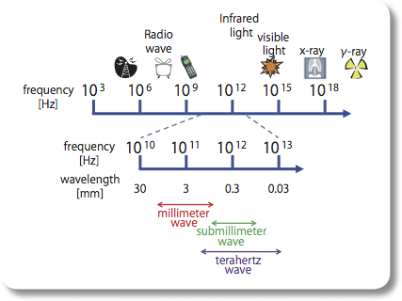
Fig. 1: Electromagnetic spectrum (taken from brochure of FIR UF)

[1] Website of FIR UF, https://dinosaur.fir.u-fukui.ac.jp/
[2] I. Workshop, F. Infrared, T. Fukui, Phys. Rev. A 100 (2019) 1.

INSTRUCTIONS

In keeping with the format, please use this template.
Authors are requested to submit an electronic version of their abstracts written in English. Abstract should start with the title in 14-pt boldfaced Times New Roman, followed by the name of the author(s), institution(s) and e-mail of the presenting author in 12-pt Times New Roman. The main text should be written in Times New Roman with font size 10.5-pt or 11-pt.

1. Write in English
2. Use A4-size paper. Top and bottom margins: 25 mm. Left and right margins: 25mm.
3. Limit the abstract length including figures, tables, and references to one page.
4. Use Times New Roman fonts. Other standard fonts (Symbol etc.) may be acceptable.
5. Presenting author should be underlined in case the presenting author is not the first author.
6. The electronic documents for the abstracts should be prepared in PDF format or MS-Word (.docx) format. We prefer PDF because MS-Word file formats sometimes depend on the PC. Please make a PDF file with embedded fonts.
7. Include the first author in the abstract file name. If more than one presentation is desired, the second and subsequent numbers should also be included.
Example of file name
T-Fukui.pdf
T-Fukui_02.pdf

Please send the electronic file(s) via the submission page on the workshop website (below).
https://felish.jp/IWFIRT2024abstract/index.html

Please check the deadline and other information on the workshop website.

